**PLC Relationships Policy**

**One Page Profile- By children for children in our PLC schools**

**Why:**

-To develop, maintain and repair relationships.

-To grow positive, healthy relationships which enable us to thrive in and out of school.

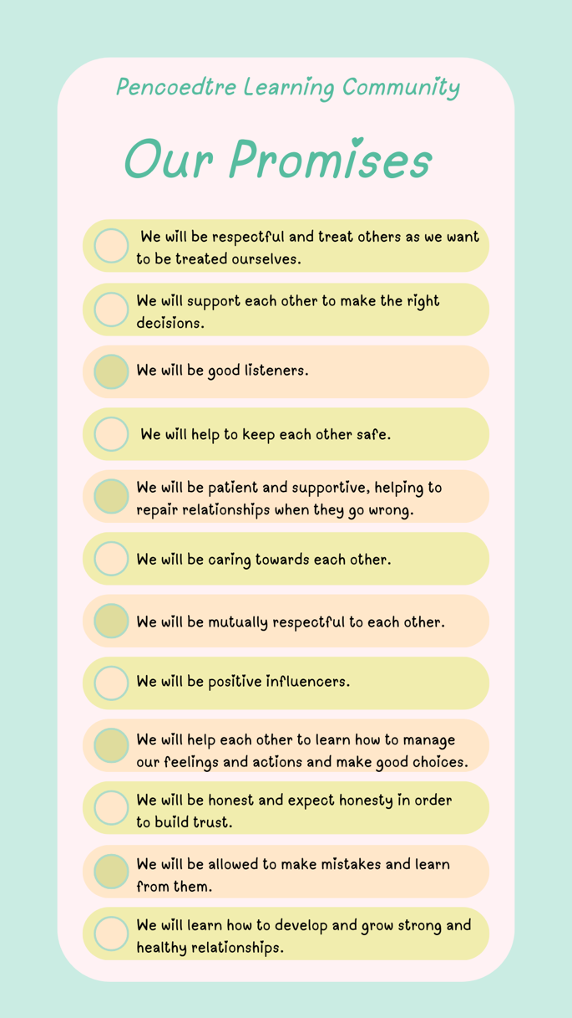**How:**

In all of our schools, we promise to learn about making positive, healthy relationships and being kind to others. Positive relationships are important to help us grow into the best versions of ourselves, and we will learn how to get along with others.

**What:** We will learn and grow as restorative schools and support one another.

We will use our promises to help us to learn.

**Restorative Approaches**

**Respect**: Listening to others’ opinions and learning to value them.

**Responsibility:** Taking responsibility for our own actions.

**Repair:** Identifying solutions that can repair harm to ensure behaviours are not repeated.

**Re-integration**: Working through a structured and supportive process that aims to solve the problems.

